D e v a y a n i
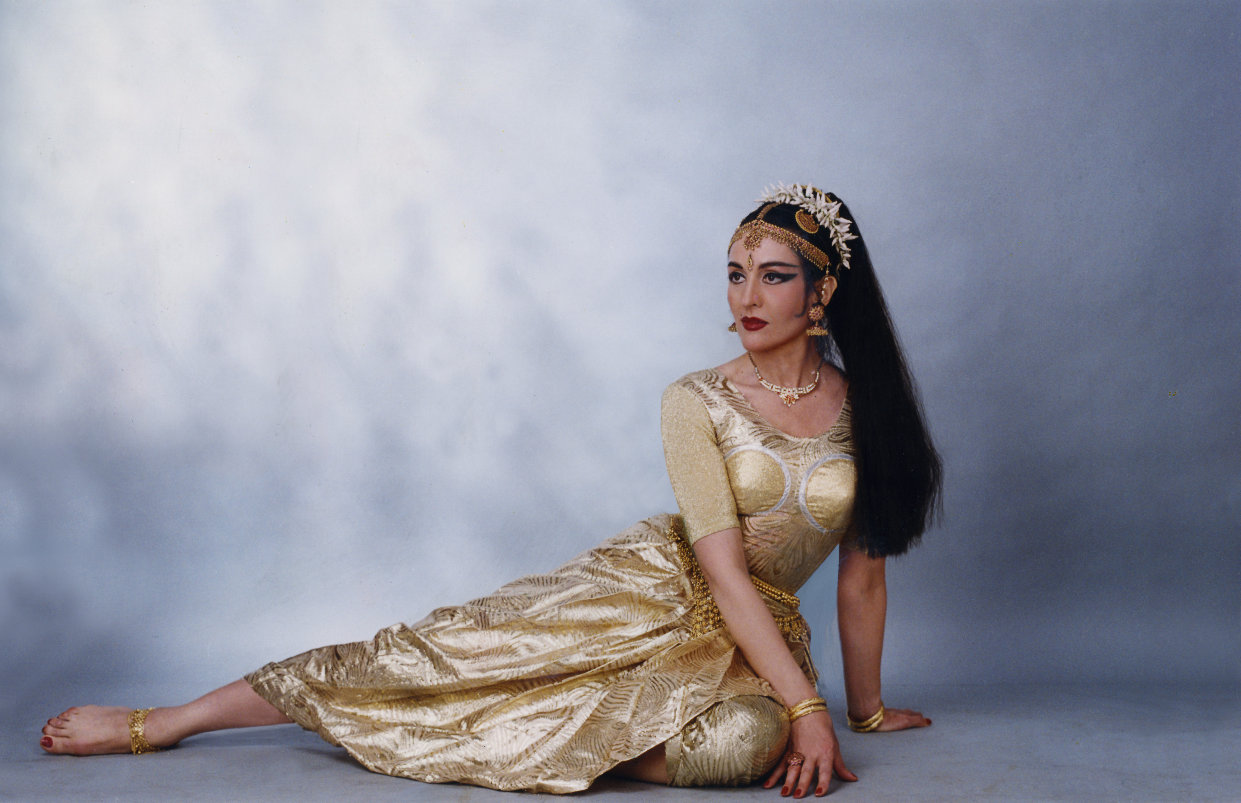

Bharata Natyam Dancer & Choreographer

Odissey of a Pioneer from France

Devayani is a foremost eminent exponent of the Classical Indian Dance style Bharata Natyam in the world. This celebrated French artist has performed in all parts of India in renowned Cultural Centres & Festivals like The Ellora Ajanta, Lucknow Mahotsav, Buddha Mahotsav, Sri Sankat Mocham Sangeet Samaroh,Chakradhar Samaroh, Modhera Sun Temple Dance Festival, Mahakal Festival Ujjain etc., and in the most prestigious Festivals and Concert Halls including in UK, France, Germany, Spain, Italy, Greece, the Scandinavian countries, Estonia, Korea, Portugal etc. Devayani is an empanelled artist with the Indian Council for Cultural Relations, Govt. of India. Devayani is a pioneer and trendsetter in many ways.

* On the 60th India’s Republic Day of January 26. 2009 Devayani was conferred by the President of India the PADMA SRI Award which is one of the highest civilian awards given to the most distinguished persons in recognition of their outstanding services & achievements. The Padma Awards Presentation Ceremony was held at Rashtrapati Bhawan, the Indian Presidential Palace on April 14.2009. DEVAYANI is the first French Classical Dancer and Foreign artist to have made it to this elite list in India in Bharata Natyam. Other prestigious awards conferred on Devayani include:

The IMM Top Cultural Ambassador Award for Excellence

The National Women Excellence Award, Yog Confederation of India Award for contribution in the field of Culture

* Devayani was given a full page coverage in the TIME & NEWSWEEK magazines amongst 70 International magazines for the ‘Real People’ campaign of the Government of India. She is the only Indian Artist who has made it to the top international magazines. A 20 feet hoarding with her Bharata Natyam pose against the backdrop of Mahabalipuram was displayed in TIMES SQUARE in 2009-2010 for the ‘Incredible India’ campaign of the Government of India.

* Devayani is the only Indian Artist and First Foreign Artist who was invited to represent Traditional Indian Dance at the World Culture Open in Seoul, Korea.

* Devayani is the First Foreign Artist to be given the top billing for her Bharata Natyam performances with the legendary opera singer Luciano PAVAROTTI at the XXIV Algarve International Music Festival in Portugal.

* Devayani is the First Foreign Artist to promote Bharata Natyam through her dance productions & workshops at the Edinburgh International Festival Fringe for several consecutive years.

* Devayani was selected by the Arts Council of England as the First Asian Dancer Artist – in – Residence to promote Indian Dance & Culture in UK.

* Devayani was the First French artist to be the heroine of an Indian Film “America Ammayi” (Telugu). Till date, fans remember her acting as the heroine of the film & her dance sequences shot in the Temple of Chidambaram.

* “As radiant as the divine celestial dancer…. gifted with a figure reminiscent of a Hindu Temple sculpture” Times of India.

* “Devayani has a powerful command of the Music … a sensuous and captivating stage presence” The Scotsman, Edinburgh International Festival.

E-mail: devayani_dance @ rediffmail.com; kumari.devayani@facebook.com
Web: www.devayanidance.com, www.facebook.com/people/Kumari-Devayani, www.youtube.com/watch?v=6t0_UzDwuFA
Telefax: 00 91 11 26910538; Mob: 00 91 9810911944

